**A**

Project Report on

#### AUTOMATIC HAND SANITIZER DISPENSER AND

#### FACE MASK DETECTION

Synopsis of the Thesis to be submitted in partial fulfillment of the requirements for

the award of the degree of

**BACHELOR OF TECHNOLOGY**

**in**

**ELECTRONICS AND COMMUNICATION ENGINEERING**

Thesis submitted by

**CH. SAI KUMAR (B151234)**

**I. RAJESHWARI (B151575)**

**P. NEELIMA (B151127)**

Under the Supervision of

**Mrs. P. Tejasvy**

**Asst. Professor in ECE department**



##### Department of Electronics and communication Engineering

**RAJIV GANDHI UNIVERSITY OF KNOWLEDGE and TECHNOLOGIES**

**Basar, Nirmal(Dist)**

**TELANGANA-504107**



**Department of Electronics and Communication Engineering**

**Rajiv Gandhi University of Knowledge & Technologies, Basar**

**CERTIFICATE**

This is certify that project Report entitled **“ Automatic Hand Sanitizer Dispenser and Face Mask Detection ”** submitted by **Mr.CH.SAIKUMAR(B151234), Ms. I. RAJESHWARI( B151575), Ms. P. NEELIMA (B151127)** Department of

Electronics and Communication Engineering , Rajiv Gandhi University of Knowledge and Technologies, Basar for partial fulfillment of the requirements for the degree of Bachelor of Technology in Electronics and communication Engineering is a bonafide record for the work and invest carried out by them my supervision and guidance

##### (Supervisor) (Head of the Department)

Mrs.P.Tejasvy, Mr. VSSKR Naganjaneyulu Gudapati

Asst. Professor in ECE, Asst. Professor in ECE,

Rajiv Gandhi University of Rajiv Gandhi University of Knowledge

Knowledge and Technologies, and Technologies, Basar

Basar



**Department of Electronics and Communication Engineering**

**Rajiv Gandhi University of Knowledge & Technologies, Basar**

**DECLARATION**

We here by declare that the work which is being presented in this project entitled, **“Automatic Hand Sanitizer Dispenser and Face Mask Detection”** submitted to RAJIV GANDHI UNIVERSITY OF KNOWLEDGE and TECHNOLOGIES, BASAR is the partial fulfillment of the requirements for the award of the degree of **BACHELOR OF TECHNOLOGY in ELECTRONICS AND COMMUNICATION ENGINEERING** is an authentic record of our own work carried out under the supervision of Asst. Professor, **Mrs.Tejasvy**. The matter embodied in this project report has not been submitted by us for the award of any other degree.

**CH**.**SAI KUMAR (B151234)**

**I.RAJESHWARI (B151575)**

**P.NEELIMA (B151127) Date: 22-05-2021**

**Place:**Basar

## Acknowledgement

We wish to express our deepest whole hearted gratitude to our project supervisor Mrs.P.TEJASVY Asst. professor in the Department of Electronics and Communication Engineering for their valuable advices and technical support from the beginning of my project.

We owe a particular debt of gratitude to Mr. V S S K R Naganjaneyulu Gudapati, Head of the Department of Electronics and Communication Engineering for his valuable guidance, significant suggestions and helping every aspect to accomplish this work.

Foremost, we would like to express my sincere gratitude to Sri. Rahul Bojja, I.A.S. is the vice chancellor of the RGUKT-Basar, for his motivation and providing all facilities to do this project.

We also extend our profound thanks to all the faculty members and lab staff who have supported and helped us throughout this project.

We wish to thank our friends, for helping us get through the difficult times, and for all the emotional support, entertainment, and caring they provided.

Finally, we love to dedicate this thesis to our family members for their sacrifice, cooperation, support, affection and patience shown during the course work which made it possible to complete this work in time.

Thank you all.

**(xxxxxxx)**

Contents :

Abstract 1

CHAPTER 1 INTRODUCTION 2-3

1.1 Introduction to Hand Sanitiser 2

1.2 Significance of Hand Sanitiser 3

1.3 Importance of Hand Sanitiser 3

1.4 Automatic Hand Sanitiser Dispenser 3

1.5 Face Mask Detection 3

CHAPTER 2 LITERATURE REVIEW 4-

CHAPTER 3 DESIGN PREREQUISITES 2-3

3.1.1 Proximity Sensor 2

3.1.2 TIP 32C Transistor 3

3.1.3 DC Water pump 3

3.1.4 9v Battery 3

3.1.5 Resistor 3

3.2 Face Mask Detection Using Machine Learning 3

3.2 Face Mask Detection Sofware Requirements 3

CHAPTER 4 PROJECT 2-3

4.1 CIRCUITRY 2

4.2 Working 3

4.3 Working model…………………………………… 3

4.3 Features 3

4.4 Applications 3

CHAPTER 5 2-3

5.1 Conclusion 2

5.2 Future Scope 2

5.3 REFERENCES 2

### ABSTRACT

###### Viruses such as COVID-19 are transferable through touch and contact. There are WHO guidelines to clean or sanitize hands regularly to reduce the risk of infection.Dispensing of sanitizer from bottle and storage would require manual intervention. In this project, we propose a novel design of touch-less sanitizer machine to reduce the risk due to contact. The system can sense the proximity with the help of proximity sensor and senses the presence of object & actuates the pump onto your hands. The sanitizer liquid dispenses through mist nozzle. With COVID -19, there arises a severe need of protection mechanisms, face mask being the primary one. Face mask acts as a key protector from disease causing virus. Our face mask detection model detects the mask on the face. Our model performs well on the test and produces reliable output.

# CHAPTER 1

# INTRODUCTION

Hygiene is an important aspect to remain healthy. There are various aspects of hygiene. A clean hand is one of them. Hands generally are touched at various surfaces and can be exposed to direct contamination. Cleaning hands at regular interval is recommended by various health organizations including WHO. Hand hygiene is now regarded as one of the most important element of infection control activities. In the wake of the growing burden of health care associated infections (HCAIs), the increasing severity of illness and complexity of treatment, superimposed by multi-drug resistant (MDR) pathogen infections, health care practitioners (HCPs) are reversing back to the basics of infection preventions by simple measures like hand hygiene. This is because enough scientific evidence supports the observation that if properly implemented, hand hygiene alone can significantly reduce the risk of cross-transmission of infection in healthcare facilities(HCFs).Evidence suggests that hand sanitization significantly reduces the transmission of healthcare-associated pathogens and the incidence of HCAI (healthcare associated infections)

## 1.2 Introduction to Hand Sanitiser

Hand sanitizer, also called hand antiseptic or hand rub, agent applied to the hand for the purpose of removing disease-causing organisms. Hand hygiene is one of the most important measures to prevent the spread of infectious diseases. Hand sanitizer use is recommended when soap and water are not available for hand washing or when repeated hand washing compromises the natural skin barrier. Although the effectiveness of hand sanitizer is variable, it is employed as a simple means of infection control in a wider areas such as day-care centre, schools, hospitals, health care clinics and super markets. As a result of rising awareness about hand hygiene and its benefits, there has been a constant increase in demand of hand sanitizers. Hand sanitizers typically come in foam, gel, or liquid form.

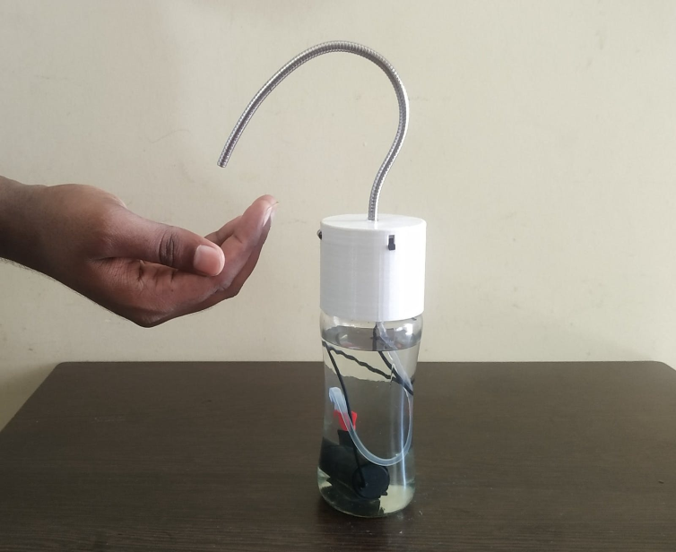

Fig.1 Hand Sanitizer

## 1.3 Significance of Hand Sanitiser

Hand Hygiene is the first and foremost thing to take care of to avoid COVID19. Centers for Disease Control and Prevention (CDC) suggest washing hands with soap and water several times a day; it reduces all the microbes, bacteria, and germs which are present on hands. But there can be several situations when you cannot get sink and water to wash hands,hand sanitizer with alcohol avails in killing 97% of germs

present on hands and prevents exposure of COVID19.

Cleaning hands at key times with hand sanitizer that contains at least 60% alcohol is one of the most important steps you can take to avoid getting sick and spreading germs to those around you.

If soap and water are not readily available, use an alcohol-based hand sanitizer that contains at least 60% alcohol, and wash with soap and water as soon as you can.

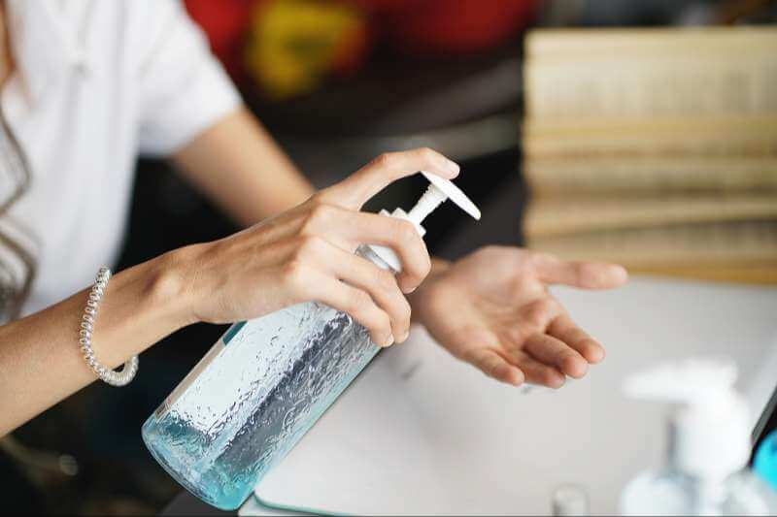

Fig. 2 Hand Sanitizer Bottle

How is Hand Sanitizer beneficial over soap?

Hand sanitizer with alcohol has several benefits over washing hands with soap and water. It is not possible to have water and sink available at every place. At times, hand sanitizers can work as a best alternative to wipe out all the germs.

Various benefits:

Hand sanitizers are very convenient and easy to carry anywhere. Just a small bottle and you are done. You do not have to seek for soap and water to wash hands.

* They are very less time-consuming,it saves your 20 seconds.
* They quickly dry and wipes out all germs.
* Handwashing is easy!Effective handwashing is a practical skill that you can easily learn, teach to others, and practice every day to prepare for an emergency.
* It doesn’t cause any roughness or dryness on the hands.
* Alcohol-based sanitizers can reduce about 97% of the bacteria on your hands.30 seconds of using hand sanitizer kills a much bacteria as two full minutes of hand washing.

## 1.3 Importance of Hand Sanitizer

Alcohol-based hand sanitizers help to deter the spread of germs and illness-causing bacteria, particularly in busy environments like schools and offices:

Stop the Spread of Germs: According to studies, 1 in 5 people don’t regularly wash their hands. Of those who do, 70% don’t use soap. Providing hand sanitizer in key areas (including bathrooms and kitchens) makes it more likely that people will use it to kill harmful bacteria.

Promote Good Hygiene and Health: A healthy building is a productive one.WHO found that encouraging the use of hand sanitizers in schools reduced absenteeism by almost 20%!

Reduce Waste: As an extra precaution, many people will use paper towels to open doors when leaving bathrooms or kitchens. Placing hand sanitizers near exits makes it easy for people to defend themselves from germs without needing to create additional mess. Proper hand hygiene can reduce absenteeism at work by up to 40%.

**1.4 Automatic Hand Sanitizer Dispenser**

Automatic hand sanitizer dispensers are completely touchless, thus requiring one to simply place their hands underneath the sensors, which will dispel the required amount of sanitizer on hands. This reduces human contact completely, unlike a traditional hand sanitizer bottle which requires to be held in hand.

That in itself is another way of contracting different viruses and bacteria. Touching the same bottle again and again by different people is unhygienic. Touch less sanitizer dispensers solve this pain point.

Sanitizer dispensers come in various designs and sizes, as mentioned earlier. However, when it comes to our cozy homes, a dispenser with a compact design that can be mounted on a wall or kept on the table suits well. The product is stationary, making it easy to sanitize hands in one place, without the hassle of figuring out where the sanitizer bottle is every time. They are easy to use by both the elders and the kids.

**1.5 FACE MASK DETECTION**

After the breakout of the worldwide pandemic COVID-19,it has called for strict measures to be followed in order to prevent the spread of disease. From the very basic hygiene standards to the treatments in the hospitals, people are doing all they can for their own and the society’s safety; face masks being the primary one. People wear face masks once they step out of their homes and authorities strictly ensure that people are wearing face masks while they are in groups and public places.

To monitor that people are following this basic safety principle, a strategy should be developed. To mitigate the spread of COVID-19 pandemic, measures must be taken. A face mask detector system can be implemented to check this. In this project, we will be developing a face mask detector that is able to distinguish between faces with masks and faces with no masks.

# CHAPTER 2

# LITERATURE REVIEW :

**2.1.”Use of alcohol Hand Sanitizer as an infection control strategy in acute care facility”**

The paper mainly says that hand washing is important and also effective with proper hand washing steps. This paper also showed the effectiveness of the alcohol based hand sanitizers, which reduced infection rates by whopping 30% and reducing significant number of pathogens.

**2.2”Impact of alcohol based hand sanitizers, antibiotic consumption and other measures on detection rates of bacteria”**

They emphasize about the use of alcohol based hand sanitizers since the alcohol based hand sanitizers had negative association with MRSA isolation rate, which means that hand hygiene is very important in hospitals

**2.2”COVID-19: Face Mask Detector With OpenCv, Keras/ Tensorflow, And Deep Learning”**

This method used the facial landmarks which allow them to detect the different parts of the faces such as eyes, eyebrows, nose, mouth, jawline etc. To use the facial landmarks, it takes a picture of a person who is not wearing a mask, and, then, it detects the portion of that person’s face.

# CHAPTER 3

**Design Prerequisites**

**3.1.1 PROXIMITY SENSOR**

**3.1.2 TIP 32C Transistor**

**3.1.3 DC Water pump**

**3.1.4 9v Battery**

**3.1.5 Resistor**

**3.1.1 PROXIMITY SENSOR**

A proximity sensor is a non-contact sensor that detects the presence of an object when the target enters the sensor’s field.Depending on the type of proximity sensor, sound, light, infrared radiation (IR), or electromagnetic fields may be utilized by the sensor to detect a target. Proximity sensors are used in phones, recycling plants, self-driving cars, anti-aircraft systems, and assembly lines. There are many types of proximity sensors, and they each sense targets in distinct ways. The two most commonly used proximity sensors are the inductive proximity sensor and the capacitive proximity sensor.

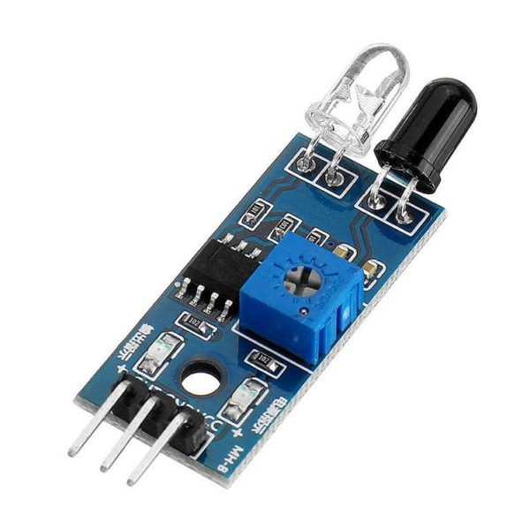

**Img.3. Proximity sensor**

An inductive proximity sensor can only detect metal targets. This is because the sensor utilizes an electromagnetic field. When a metal target enters the electromagnetic field, the inductive characteristics of the metal change the field’s properties, thereby alerting the proximity sensor of the presence of a metallic target. Depending on how inductive the metal is, the target can be detected at either a greater or shorter distance.

Another type of proximity sensor is called a [photoelectric proximity sensor](https://www.motioncontroltips.com/what-are-proximity-sensors/). There are two main types of photoelectric proximity sensors: reflective and through-beam.

Reflective proximity sensors detect objects when the light emitted from the sensor is reflected back at the photoelectric receiver. Through-beam sensors detect targets when the target breaks the beam of light between the sensor’s emitter and receiver.

**Pin Description**

**VCC:** power supply 3.3 – 6 V.

**GND**: Ground.

**OUTPUT:** output value is a dc value. If output is greater than threshold value output is 1 otherwise output is 0.

**3.1.2 TIP 32C Transistor**

The TIP32 is a PNP Power transistor. Since it has high collector current of about 2A it can be used for Power switching or large signal amplification. The transistor is mainly known for its high amplification capacity since 2A is not much of a higher capacity. So, if you are looking for a PNP transistor for your amplifier circuit then TIP32 might be your choice or to switch higher current loads more than 2A, try logic level MOSFETS like [IRF540N](https://components101.com/irf540n-pinout-equivalent-datasheet)(N-channel) which also operates at 5v.

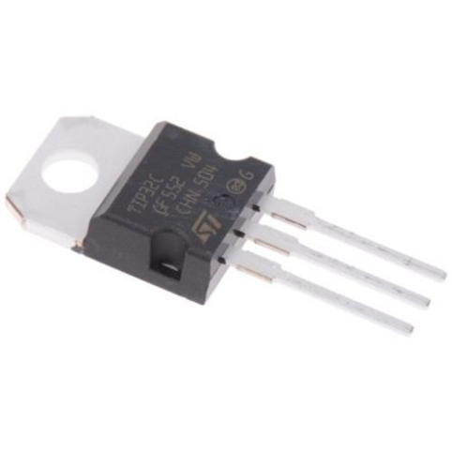 **Img.4.Tip 32C Transistor**

**Applications:**

1.Can be used as medium Power switches

2.Large signal amplification

3.Speed control of Motors

4.Half bridge circuits

5.High current switching (up to 2A) loads

6.Inverter and other rectifier circuits

**Features:**

* Medium-power PNP Transistor
* DC Current Gain 10 to 50
* Continuous Collector current (IC) is 3A
* Collector-Emitter voltage (VCE) is 100 V
* Collector-Base voltage (VCB) is 100V
* Emitter Base Voltage (VBE) is 5V
* Available in To-220 Package

**3.1.3 DC WATER PUMP**

A submersible pump pushes water to the surface by converting rotary energy into kinetic energy into pressure energy. This is done by the water being pulled into the pump: first in the intake, where the rotation of the impeller pushes the water through the diffuser. From there, it goes to the surface.

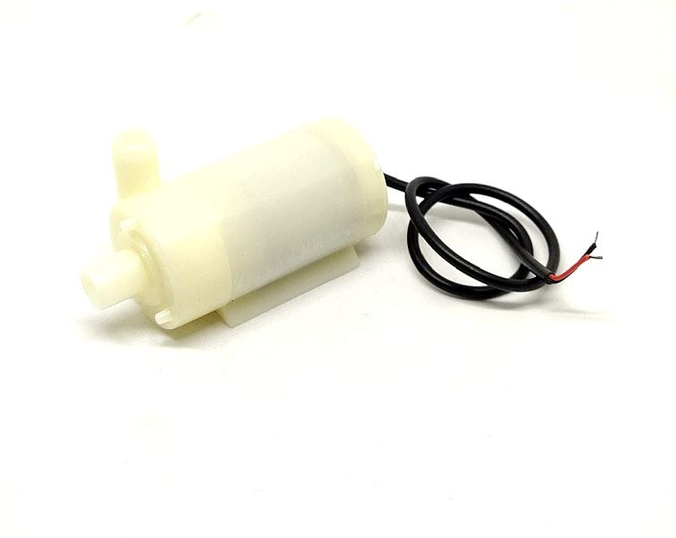

**Img.5.Submersible Pump**

|  |  |
| --- | --- |
| Number Of Stages | Single-stage Pump |
| Usage/Application | Sanitizer |
| Type | Sanitizer |
| Motor Phase | Single Phase |
| Type Of Submersible Pumps | 5V DC water pump |
| Motor Voltage | 3V - 5V |

**3.1.4 9V BATTERY**

A nine**-**volt battery, either disposable or rechargeable, is usually used in smoke alarms, smoke detectors, walkie-talkies, transistor radios, test and instrumentation devices, medical batteries, LCD displays, and other small portable appliances

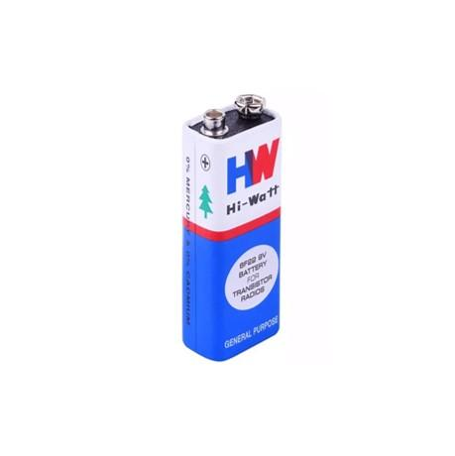

**Img.6. 9v Battery**

**3.1.5 RESISTOR**

A resistor is a passive two terminal electrical component that implements [electrical resistance](https://en.wikipedia.org/wiki/Electrical_resistance) as a circuit element. In electronic circuits, resistors are used to reduce current flow. Resistors are common elements of [electrical networks](https://en.wikipedia.org/wiki/Electrical_network) and [electronic circuits](https://en.wikipedia.org/wiki/Electronic_circuit) and are ubiquitous in [electronic equipment](https://en.wikipedia.org/wiki/Electronics).

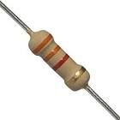

**Img.7.Resistor**

**3.2 Face Mask Detection Using Machine Learning :**

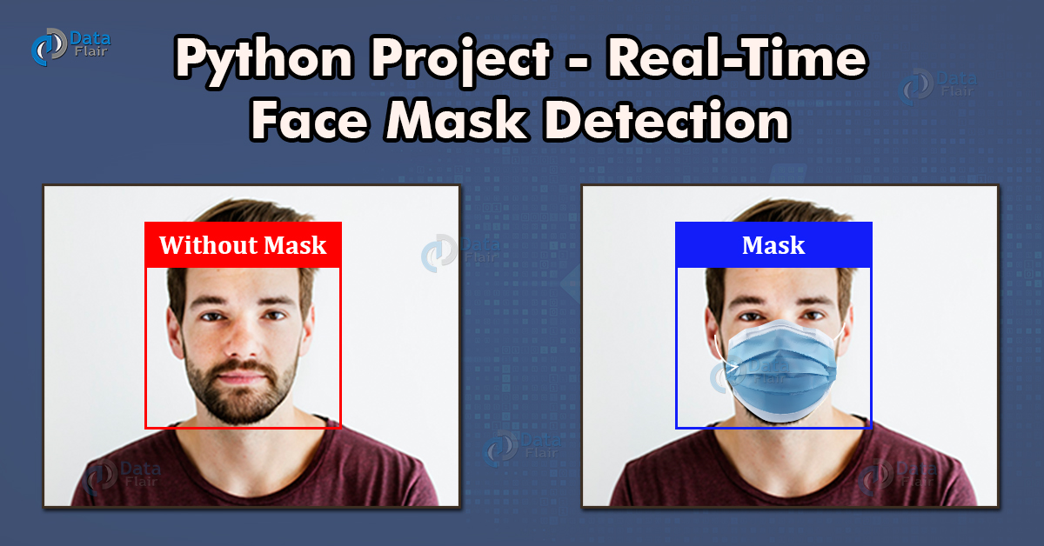

**Img.8. Face Mask Detection**

**3.2 Face mask detection Software**

**requirement Specification**

We can use any OS like windows,ubuntu

Tensorflow / pytroch backend

Anaconda python platform with jupyter notebook

**Technologies used**:

**OpenCv:** **OpenCV** is a huge open-source library for computer vision, machine learning, and image processing. OpenCV supports a wide variety of programming languages like Python, C++, Java, etc. It can process images and videos to identify objects, faces, or even the handwriting of a human.



**Img.9. OpenCv**

**SUPPORT VECTOR CLASSIFICATION:**

* Support vector machine(svm) has both classification as well as the regression model(svr).The SVC model is a categorical model in which we draw a line based on the outcomes but in this classification model we draw a hyperplane based on the outcomes.
* The hyperplane separates the upper points and lower points and points near the hyper plane are called support vectors which are helpful in calculating the errors from all the points.

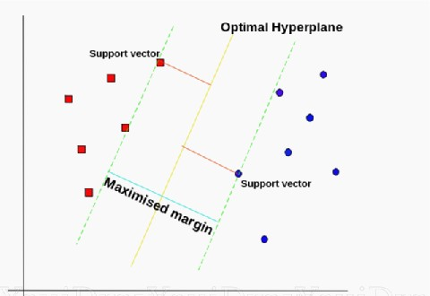

**Img.10. Example of Support Vector Classification**

**NUMPY:**

* NumPy, which stands for Numerical Python, is a library consisting of multidimensional array objects and a collection of routines for processing those arrays. Using NumPy, mathematical and logical operations on arrays can be performed.
* This tutorial explains the basics of NumPy such as its architecture and environment. It also discusses the various array functions, types of indexing, etc.
* An introduction to Matplotlib is also provided. All this is explained with the help of examples for better understanding.

**Matplotlib:**

* Matplotlib is one of the most popular Python packages used for data visualization.
* It is a cross-platform library for making 2D plots from data in arrays. It provides an object-oriented API that helps in embedding plots in applications using Python GUI toolkits such as PyQt, WxPythonotTkinter.
* It can be used in Python and IPython shells, Jupyter notebook and web application servers also.

**Flowchart**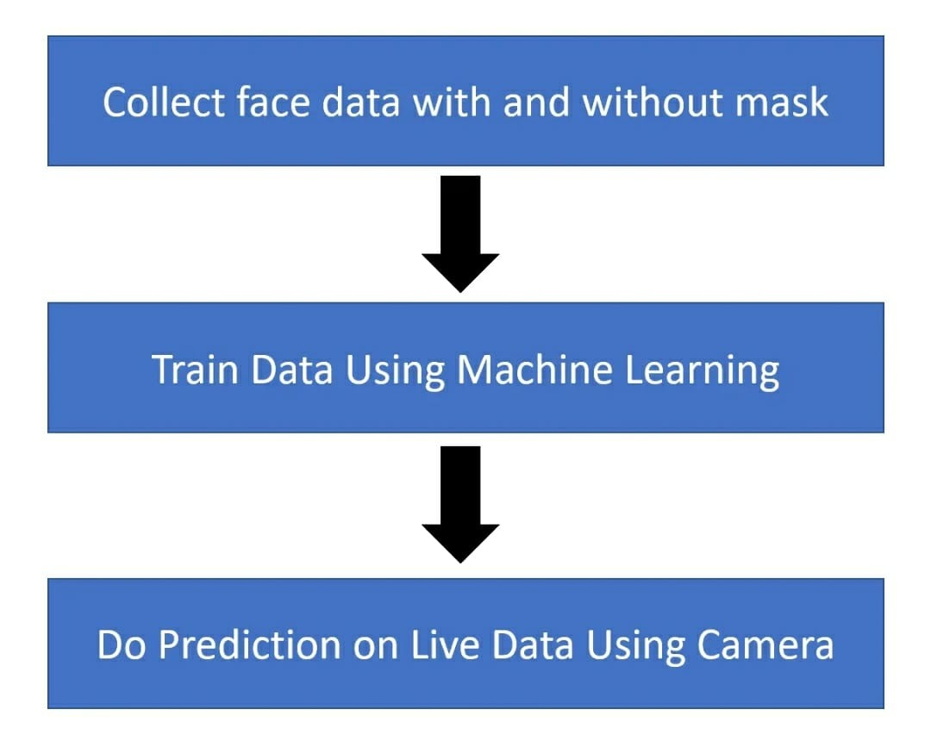

# CHAPTER 4

**PROJECT**

**4.1 CIRCUITRY**

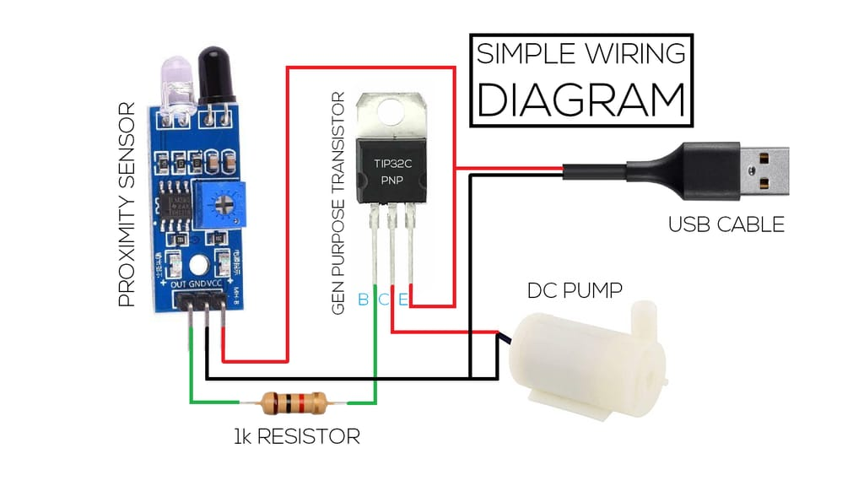

**Fig.11. Circuit Diagram For Automatic Sand Sanitizer**

**4.2 WORKING**

Here important parts of the program are explained.

Automatic Hand Sanitizer provides truly touch less experience. It’s fast, safe, and simply more efficient.

* The automatic hand sanitizer works using the proximity sensor to check the presence of hands below the outlet of the sanitizer model. It will continuously detects the objects near the sanitizer outlet and turns on the pump whenever the object is found.
* It uses a mini DC submersible pump detecting the movement of the hand with the help of proximity sensor and pumps the sanitizer.
* It will Automatically spray into the palm of your hand, and then rub your hand together briskly until dry.
* It dispenses any alcohol-based sanitizer. Once the hand removed from the range of sensor, it would Turn off automatically.

**4.3 WORKING MODEL FOR AUTOMATIC HAND SANITIZER:**

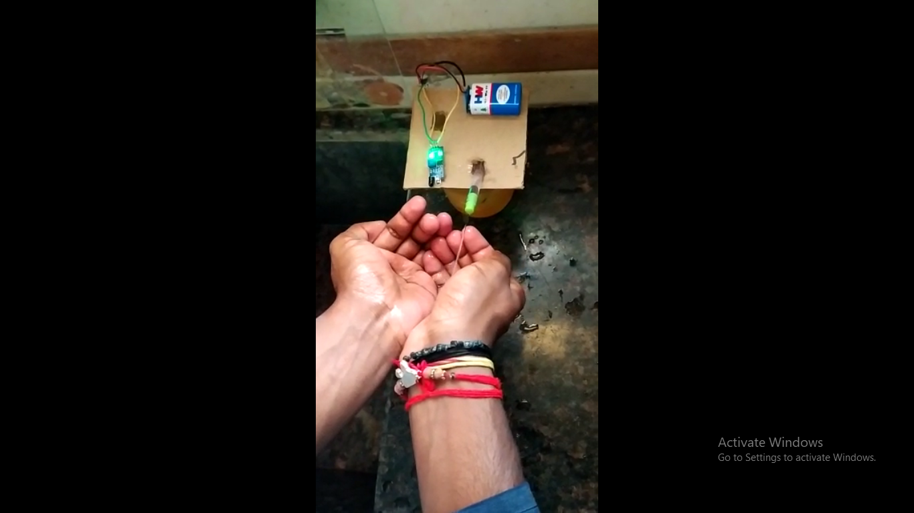

**Fig.12. Hands before the sensor**

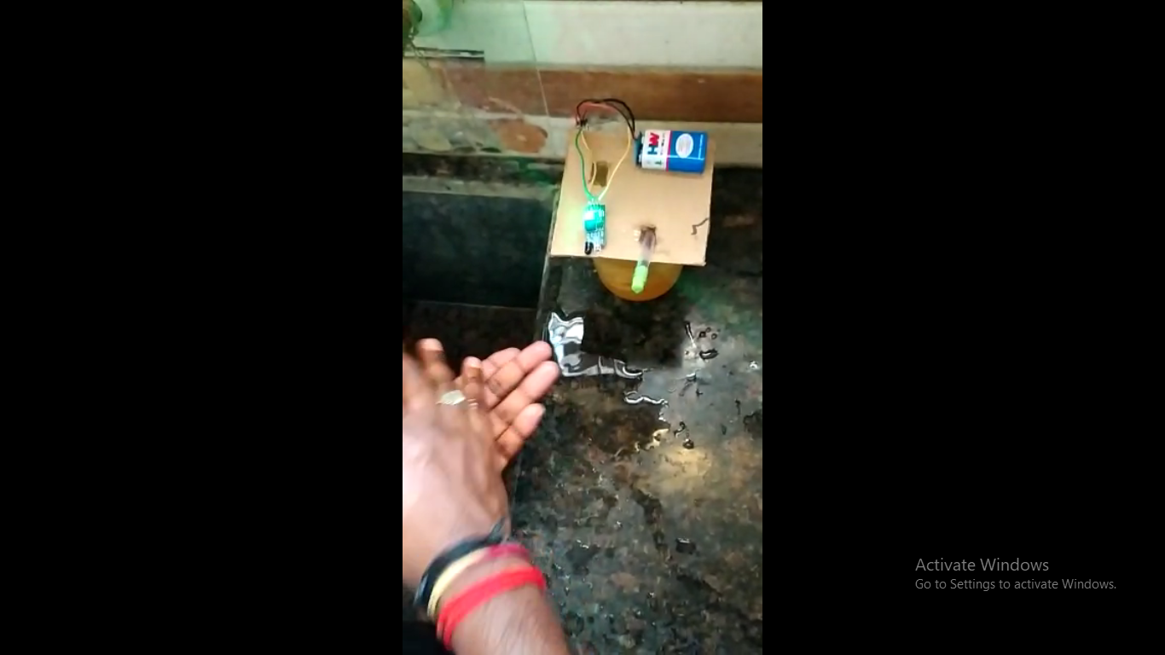

**Fig.13. Hands not before sensor**

In this working model, we used the sensor called proximity sensor which is used for detecting the obstacle. When we put our hand in front of sensor, the sensor output will become high and the submersible pump is activated, from this pipe the sanitizer is poured in to our hands.

**WORKING MODEL FOR FACE MASK DETECTION:**

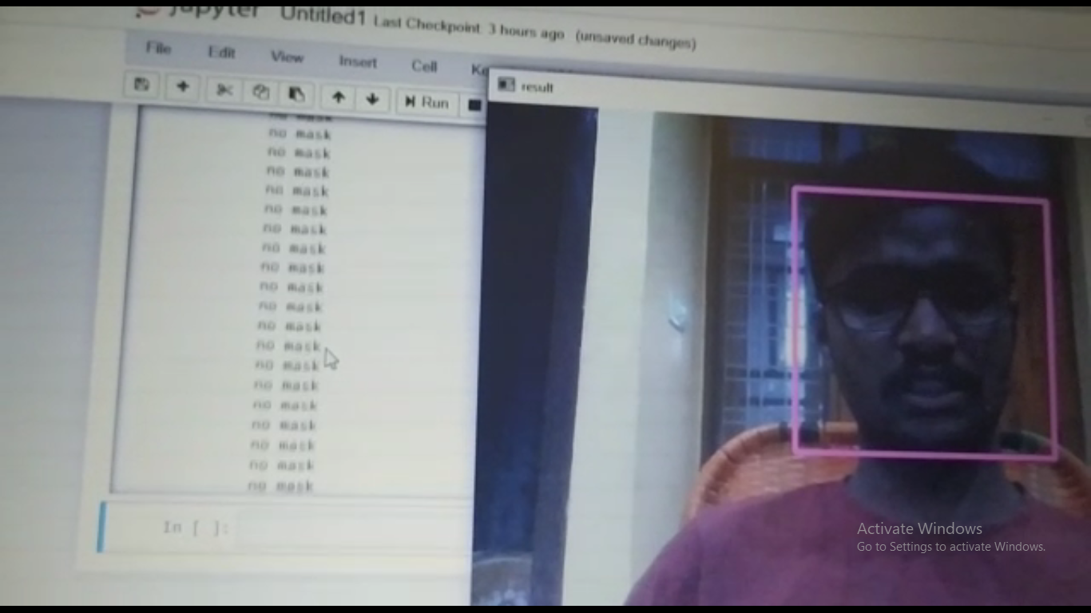

**Fig.14. Face without mask**

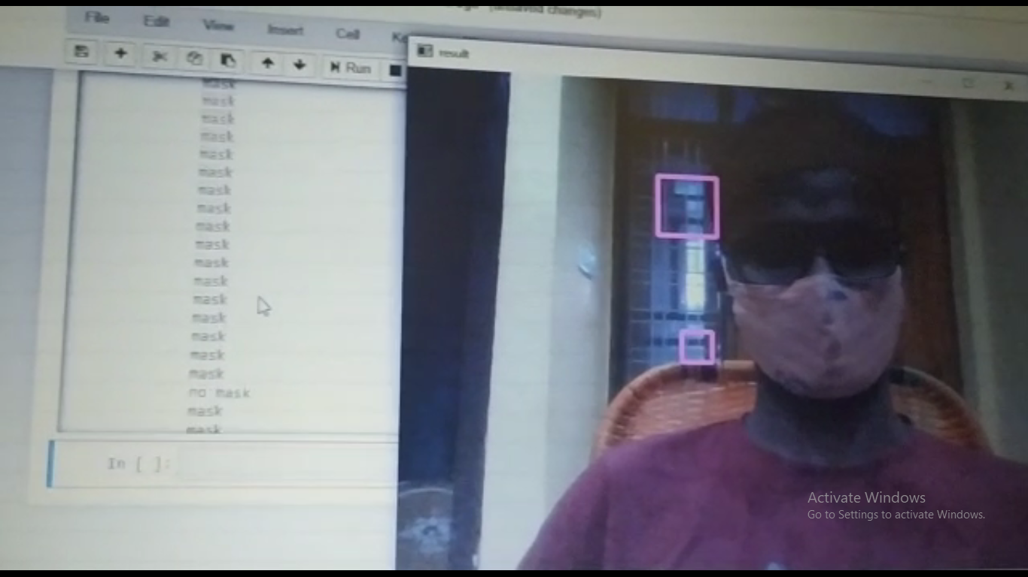

**Fig.15. Face with mask**

In this model, we used OpenCv and machine learning classification model like Supported Vector Classification.From OpenCv first we got the image from the live video streaming with the built-in camera of the laptop and trained the machine. Now the machine became

trained and it giving nice predictions with and without mask.

**Code For Face Mask Detection:**

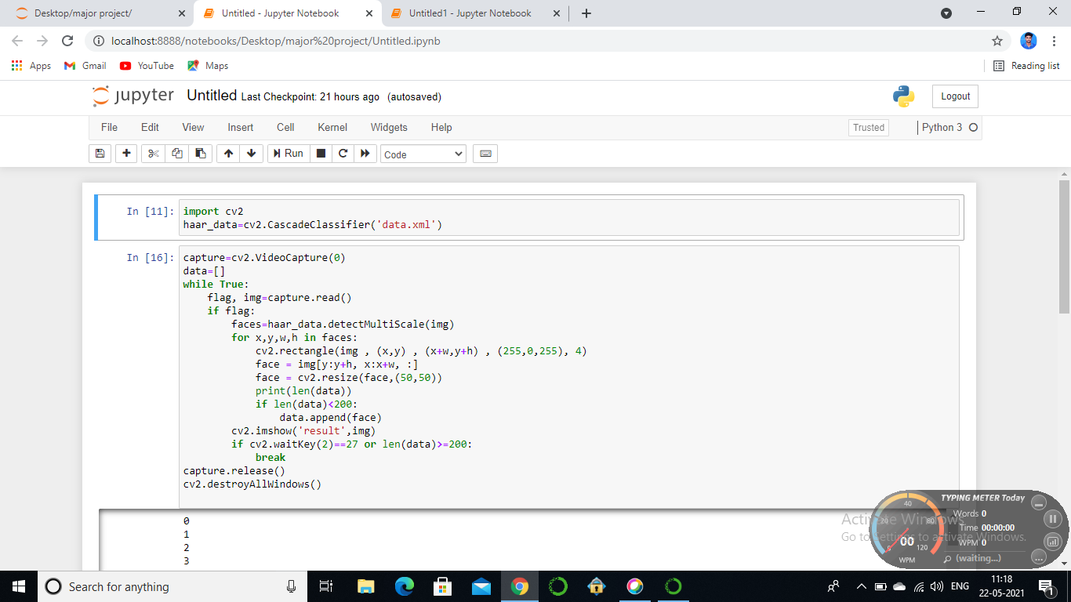

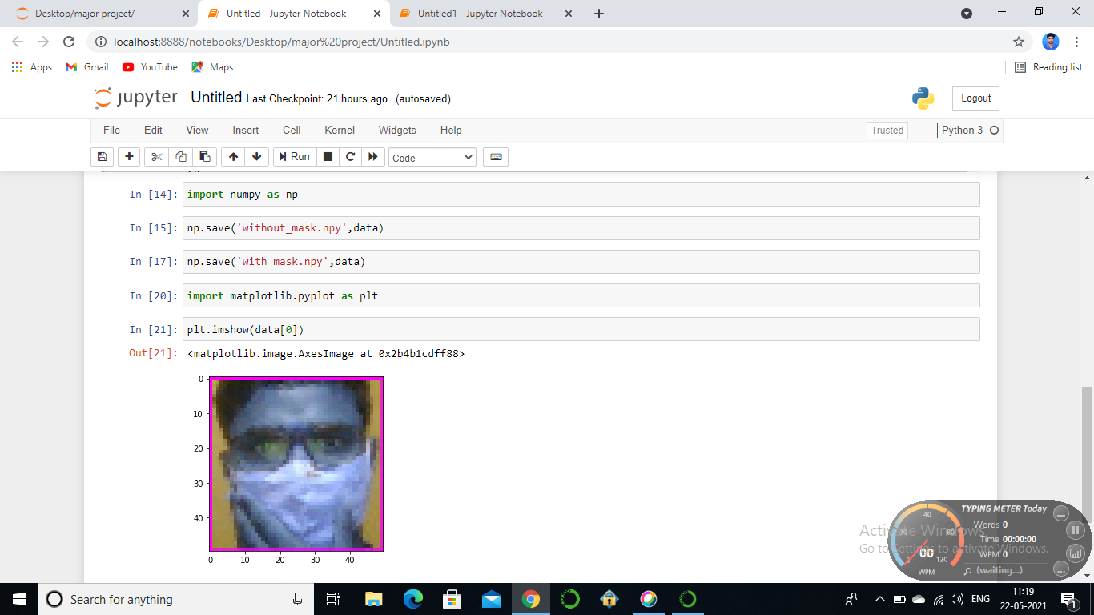

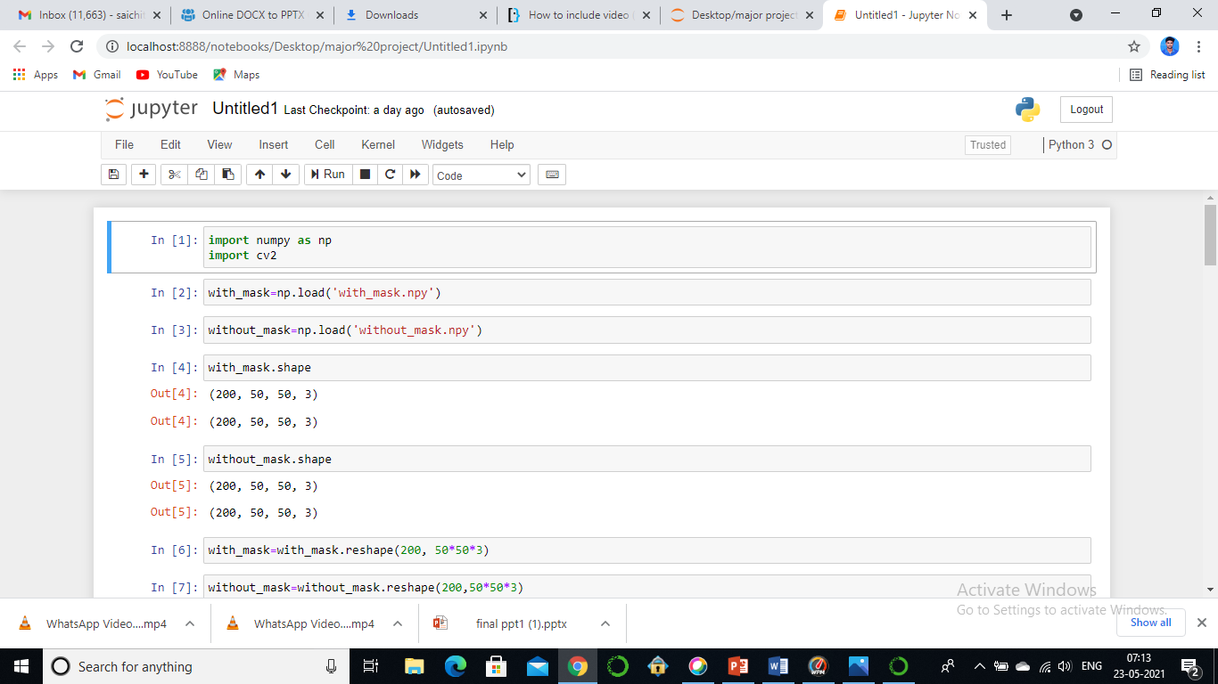

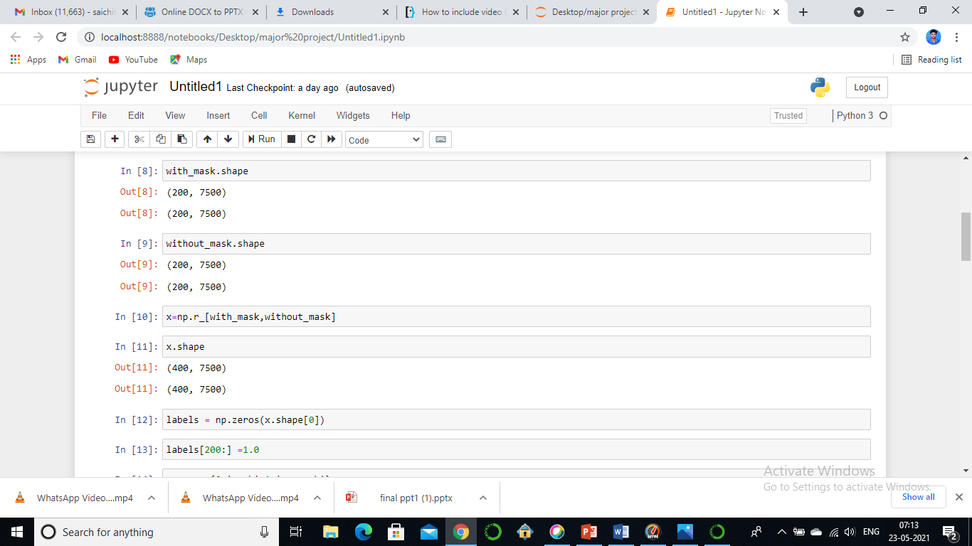

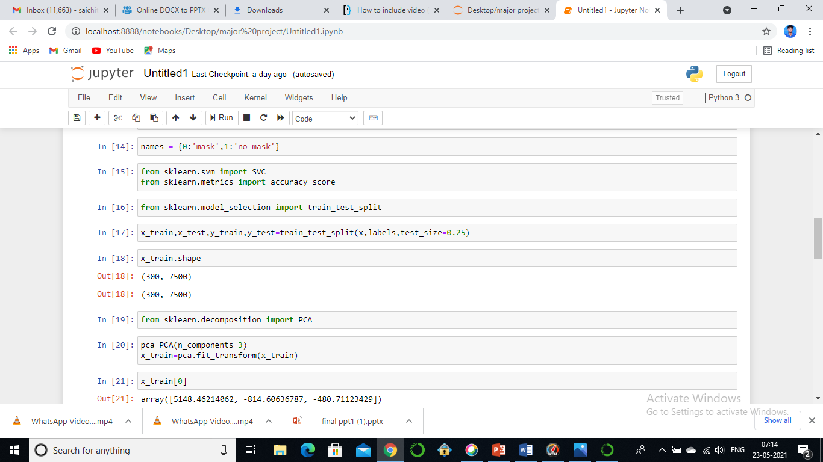

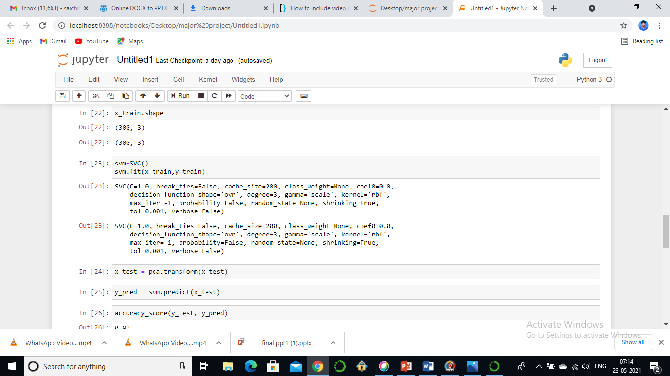

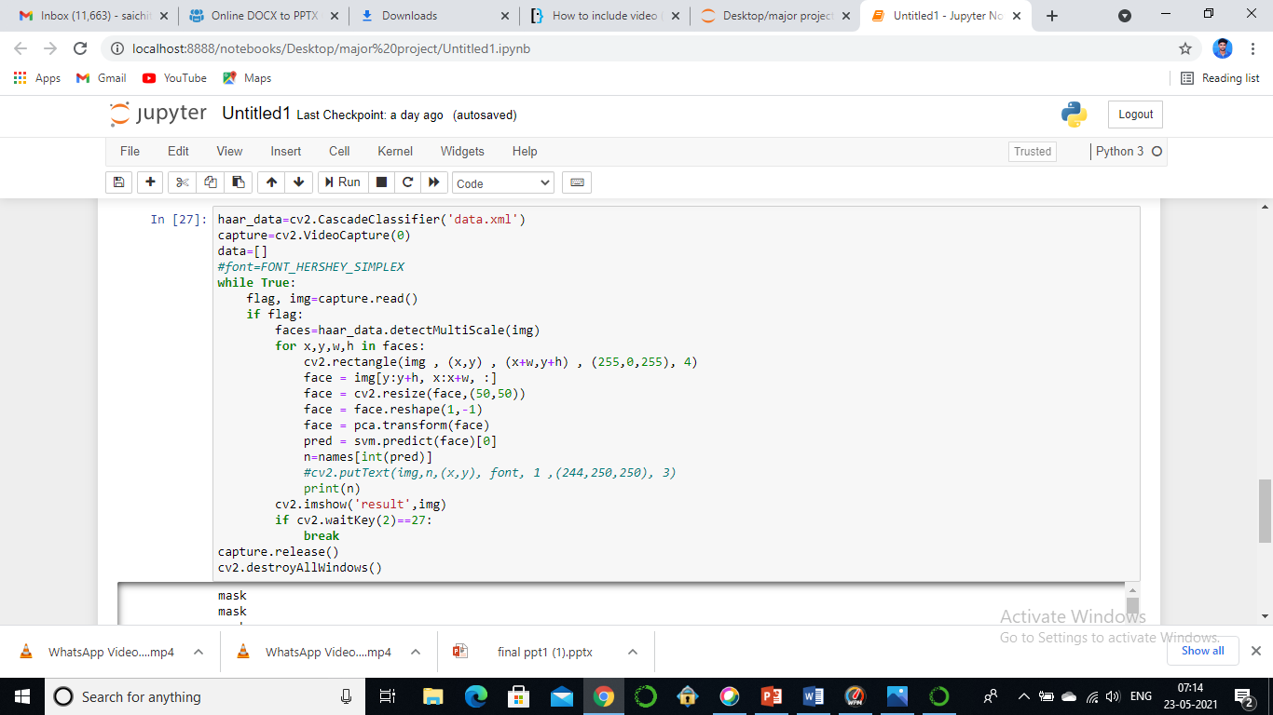

**4.4 FEATURES**

* Automatic- provides truly touch less experience. It’s fast, safe, and simply more efficient.
* Low Cost- It can be implemented with less cost.
* Easy accessibility- can be placed anywhere, convenient way to maintain hygeine control practices.
* Eliminates the contact point.
* Automatic hand Sanitizer was made under limited resources but is functional.
* Ideal for busy areas as well as less densely populated spaces, based on variants available.
* Efficient face mask detection
* reliable mask detection of an individual

**4.5 APPLICATIONS**

* It can be installed at Entry Gate,Waiting areas,Educational institutes,Hospitals,clinics,banks,ATM’s.
* At Public Places for easy detection of face masks.
* At Workspace to use hand sanitizer easily.
* Hospital setting for patients benefit.
* Near your Locality for safety.
* Face mask detection can be used in many areas like security, biometrics.

# CHAPTER 5

**5.1 CONCLUSION**

Automatic hand sanitizer dispensers are better than the traditional ones as they dispense the sanitizer automatically. Touch less automatic hand sanitizer dispensers offer an extra layer of protection. They can be placed in workspaces,Institutions, offices,crowded areas. This model is simple,cheap and much more efficient version of touch less sanitizer dispenser. Hence,Automatic hand Sanitizer dispenser can be used in many places to avoid spreading of germs and to ensure hygiene of people. This reduces human contact completely, unlike a traditional hand sanitizer bottle which requires to be held in hand. Automatic hand sanitizer takes less time to use than traditional hand washing method.

To mitigate the spread of COVID-19 pandemic, measures must be taken. We have modeled a face mask detector,which detects the face with no mask on the face. It is also computationally efficient and easier to install the model.

**5.2 FUTURE SCOPE**

Automatic hand sanitizing machine to improve hygiene and prevent the infectious viruses entering our body.These automatic hand sanitizer machines are developed keeping in mind about its affordability by underprivileged sections of the society as it can be purchased by lower income groups in pursuit of their well being and also they are easily available and can be used by everyone without any hassle.More than fifty countries around the world have recently initiated wearing face masks compulsory. People have to cover their faces in public, supermarkets, public transports, offices, and stores. Retail companies often use software to count the number of people entering their stores. Software operators can also get an image in case someone is not wearing a mask. Furthermore, an alarm system can also be implemented to sound a beep when someone without a mask enters the area.

**REFERENCES**

[1].<https://www.amazon.in/NETBOON-Automatic-Sanitizer-Dispenser-Technology/dp/B08CSJBX9Z>

[2].https://shareok.org/bitstream/handle/11244/11052/Wan_okstate_0664D_12910.pdf .

[3].<https://www.digikey.com/en/maker/blogs/2020/make-an-automatic-hand-sanitizer-dispenser-using-arduino>.